Analysis of Alphabet Inc.'s Investment Potential

Highlights

- Alphabet Inc., parent company of Google, has shown steady growth, with an average closing stock price of $131.97 and moderate fluctuations.
- The company's shares experience robust daily trading volume of about 30.76 million, indicating strong investor interest.
- Alphabet Inc.'s opening, high, low, and closing prices tend to closely align, indicating stability by the market's close despite daily fluctuations.
- The stock's volatility, reflected in a mean daily return of -0.1369% and a standard deviation of 0.01731, suggests caution for long-term investors but opportunities for short-term traders.
- The 20-day and 60-day moving averages offer insights into short-term and long-term trends, with crossovers signalling potential bullish or bearish trends.

Alphabet Inc., a leader in the technology sector, operates at the forefront of innovation across multiple high-tech domains. As a publicly traded entity on NASDAQ, its significant trading volumes and price fluctuations reflect a mix of investor sentiment, company performance, regulatory changes, and broader economic conditions. This dynamic makes Alphabet a key subject of analysis for investors, policymakers, and market enthusiasts alike. The company's broad engagement in sectors like artificial intelligence and autonomous driving not only cements its market position but also continuously shapes the technological landscape. For investors, analysing Alphabet's market behaviour is crucial for assessing investment risks and spotting growth opportunities.

Similarly, regulators and policymakers gauge its impact on technological advancement and market competition. In this context, monitoring Alphabet's activities—from trading volumes to stock price movements—is essential for understanding its market stance and the wider implications for the digital economy. This ongoing analysis is vital in a rapidly evolving world where digital innovations reshape economic and consumer landscapes, offering a strategic view that aids decision-making in various sectors.

Market & Stock Analysis

Alphabet Inc., the parent company of Google, maintains an average closing stock price of $131.97, illustrating a steady market presence. Despite this apparent stability, the stock price does experience fluctuations. These changes are often reactions to new market information, earnings reports from the company, and shifts in the economic landscape, showcasing how external events can influence investor behaviours and stock value.

On a typical day, about 30.76 million shares of Alphabet are traded, indicating a high level of interest and activity. This volume tends to increase significantly during times when there are important updates about the company or notable economic events, highlighting how sensitive the market is to news and changes.

This story of Alphabet’s trading highlights the intricacies of stock market dynamics, where investor sentiment can shift rapidly based on new information. Understanding these shifts is crucial for anyone looking to invest in the stock market, as it helps in making informed decisions about when to buy or sell shares based on more than just the price. An examination of the stock's daily price movement specifically the opening, high, low, and closing prices shows a general alignment, suggesting that despite intraday fluctuations, the stock price tends to stabilize by the close of trading. This behaviour is critical for investors, particularly for setting strategic trading parameters such as stop-loss and take-profit orders, which hinge on understanding intraday volatility.

Alphabet Inc.'s trading activities reveal an intriguing pattern: the price at which the stock opens the market tends to be a reliable indicator of where it will close. This consistency provides a valuable tip for day traders, allowing them to predict how the stock is likely to perform by the end of the day based on its opening price. Additionally, there is an interesting relationship between the number of shares traded and the movement in stock prices. Typically, when more shares are traded, prices initially drop. This could be due to many investors choosing to sell their shares, driving the price down. However, this decrease is often temporary, as prices might recover later in the day, adding a twist to the usual expectations about how trading volume impacts stock prices.

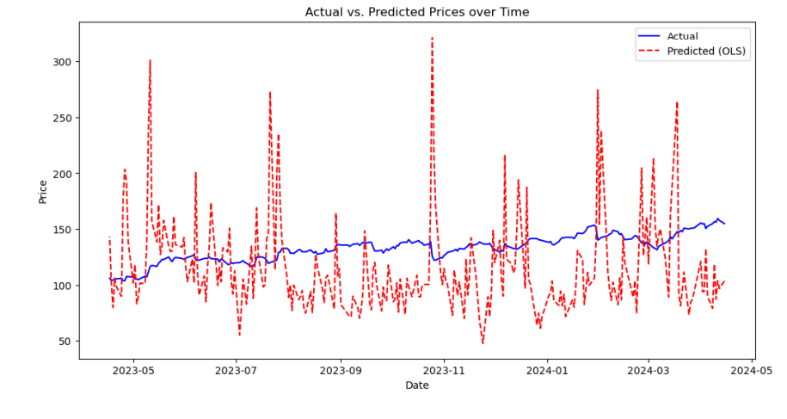
In our detailed review of Alphabet Inc.'s trading patterns, we've discovered a strong link between the number of shares traded daily and the stock's closing price. This finding is invaluable for investors and traders seeking to refine their market strategies. By keeping an eye on changes in trading volume, which often precede shifts in stock prices, market participants can predict and react to price movements more effectively. This relationship between trading volume and price allows investors to make well-timed decisions, potentially leading to more profitable trades. For instance, a surge in trading volume could signal an upcoming rise in stock prices, giving traders a chance to buy before the price peaks.

However, our analysis also cautions against relying solely on trading volume. It's a helpful indicator, but it's not the whole picture. Other factors like market trends, news events, and economic indicators also play critical roles in shaping stock prices. For this reason, the most successful investors use a blend of signals and indicators to guide their trading decisions. This not only improves the accuracy of predictions but also helps manage risks more effectively. In the fast-paced world of stock trading, such a comprehensive approach is essential for navigating market complexities and achieving investment success.

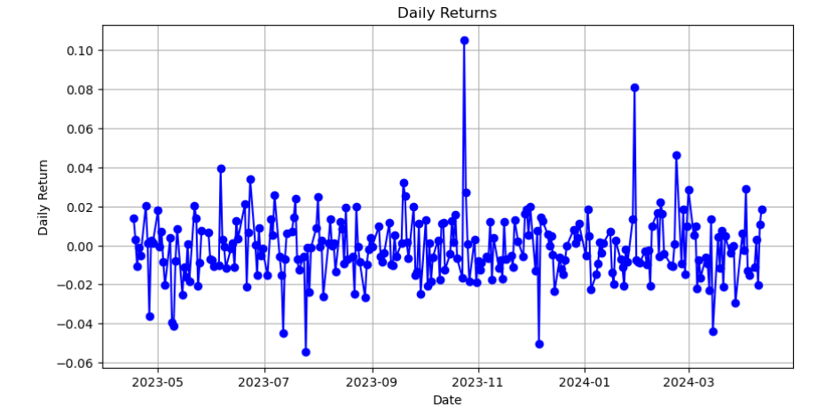

Alphabet Inc.'s stock has shown noticeable daily price changes over the analysed period, averaging a slight decrease in value by about 0.14% each day. This pattern suggests that the stock experienced more down days than up days during this time, pointing to a somewhat challenging market environment for the stock. Despite this average decrease, the stock’s daily price movements varied widely, ranging from a drop of about -5.46% to a rise of over 10.50% on different days. This range indicates that on any given day, the stock could either experience significant losses or gain substantially, highlighting its unpredictable nature during this period. Such variability in daily returns reflects the stock's highly volatile nature, suggesting that it could be influenced by a variety of factors, and it also underscores the potential for both risk and reward as investors could see significant returns on some days, but they also face the possibility of notable losses on others.
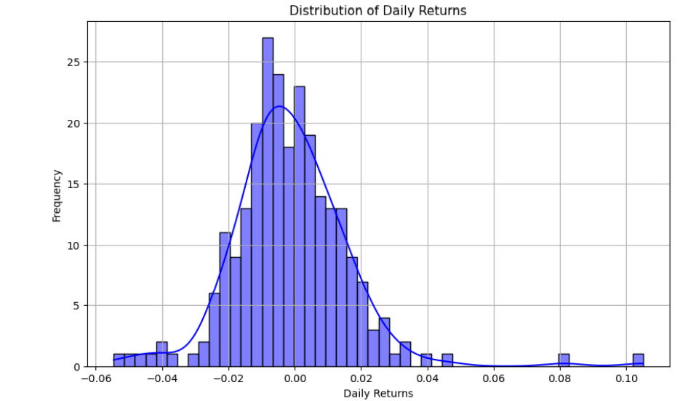
The volatility analysis of Alphabet Inc. shows a pattern in its daily stock returns that is mostly steady and predictable, much like what you might expect from a well-established company. Most days, the stock's performance doesn't stray far from the average, showing a kind of consistency that investors can rely on. However, there are also days when the stock sees larger swings, both up and down. This range in performance tells us that while Alphabet is generally stable, it has days of significant movement that could mean higher gains or increased losses.

The daily shifts in Alphabet Inc.'s stock prices paint a diverse picture for the investing community. For conservative investors who prefer stability, Alphabet's generally steady performance may be particularly appealing. However, for those who seek larger profits and are comfortable with taking on more risk, the occasional sharp increases in stock value present exciting opportunities. This versatility makes Alphabet a compelling choice for a broad range of investment strategies and preferences.

Understanding the variability in Alphabet's returns is crucial for investors, as it provides a clear gauge of the potential risks and rewards associated with the stock. The greater this variability, the higher the risk, which is an important consideration for portfolio managers who must align investment choices with their clients' appetite for risk. While the overall downward trend in daily returns might warrant a cautious approach for those thinking about long-term investments, the stock's frequent fluctuations offer ample opportunities for short-term traders to capitalize on. By paying close attention to the stock's performance on days that deviate from the norm, investors can gain valuable insights into how Alphabet reacts to specific market events. This knowledge is invaluable in honing investment strategies that can adapt to both short and long-term financial goals.

Comparison of GOOGL and IXIC Stock Performance

Alphabet Inc., with its closing prices closely following a steady upward trajectory, showcases consistent growth, echoing the resilience and strategic positioning of the company in the market. This growth is not just a number; it represents Alphabet's robust engagement in the technology sector and its significant role within broader market trends. The company's stock prices have a notable connection with the NASDAQ Composite Index, evidenced by their movements often mirroring each other. This correlation highlights Alphabet’s influential position within the index, making it a barometer for the tech giant's performance. Investors might look to the NASDAQ as a reliable reference point when evaluating Alphabet's stock, given their aligned movements. Despite Alphabet’s importance in the market, it tends to display more stability than the broader NASDAQ index, which shows greater variability. This stability is a testament to Alphabet's solid market strategies and its adeptness at maintaining a steady course amid the usual market fluctuations.

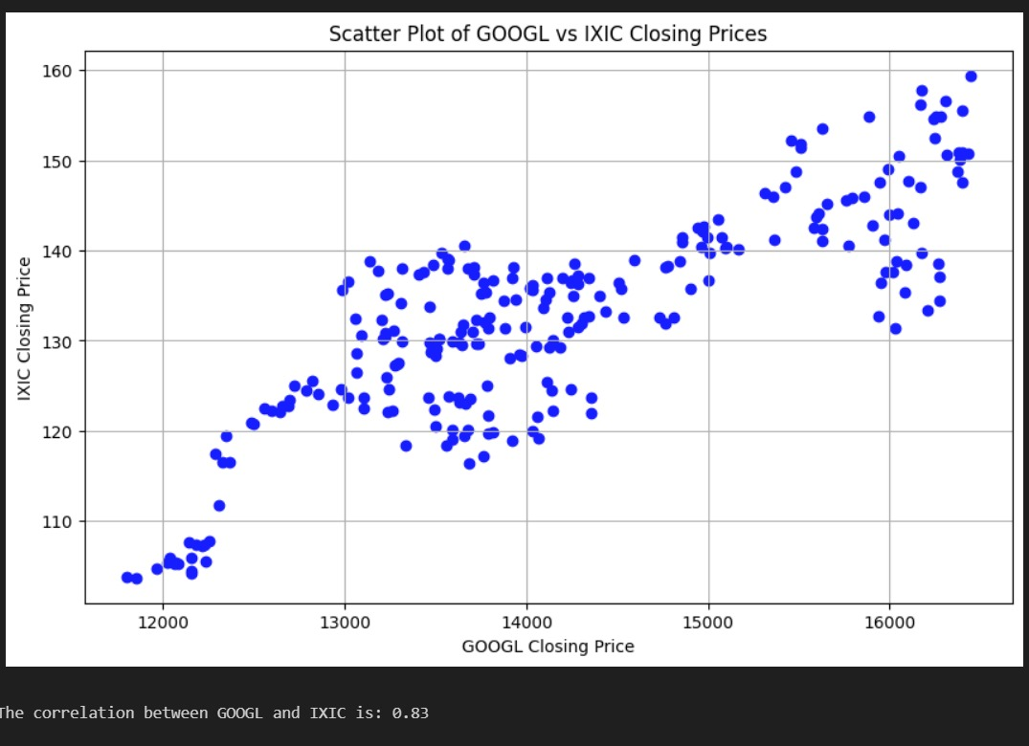

The story of Alphabet Inc. (GOOGL) in comparison to the NASDAQ Composite Index (IXIC) unfolds a narrative of stability and growth within the technology sector. The alphabet, with its upward trajectory, demonstrates a firmness that attracts long-term investors looking for a reliable place to grow their investments amidst the usual ups and downs of the market. This consistent growth speaks volumes about investor confidence in Alphabet, painting it as a beacon of stability in a sea of uncertainty. On the other hand, the NASDAQ Composite, while also on an upward path, mirrors the expected volatility of a composite index. This index, representing a broad spectrum of tech stocks, experiences more noticeable fluctuations. These movements reflect the varying fortunes of the many companies it comprises, highlighting the diversity and dynamism of the tech sector. The day-to-day changes in stock prices further color the story, offering a glimpse into the short-term sentiments that sway the market. For investors and market watchers, these daily shifts are a canvas, displaying the immediate reactions of the market to the latest news or economic indicators.

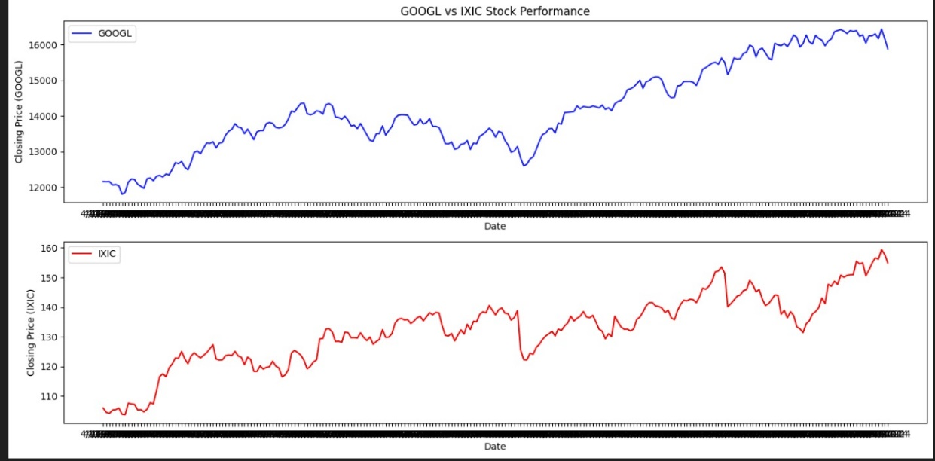

Daily Percentage Change in Closing Price
The recent analysis presents a day-to-day review of the closing prices for Alphabet Inc. (GOOGL) and the NASDAQ Composite Index (IXIC), shedding light on their stability and reactions within the technology sector. For Alphabet Inc., daily shifts in closing prices tend to stay within a narrow range of -2% to +2%. These moderate changes are particularly attractive to investors who prefer to steer clear of big risks and value consistency in their investments. This pattern underscores Alphabet’s role as a solid player in the technology field, offering a sense of security amidst the often-unpredictable market.

On the other hand, the NASDAQ Composite Index, which includes a broad spectrum of tech companies, shows more pronounced fluctuations in its daily closing prices, with variations sometimes ranging from -8% to +6%. This greater degree of volatility indicates that the index is more responsive to immediate market news and overall economic shifts. For investors who specialize in seizing short-term opportunities, these larger swings can provide a fertile ground for strategic trades, capitalizing on the quick changes.

This contrasting behaviours between GOOGL and IXIC highlights different investment appeals: Alphabet Inc. offers stability and a lower-risk profile, suitable for those looking for steady growth. In contrast, the NASDAQ Composite attracts those looking to engage more directly with the market's ebbs and flows, leveraging these movements for potential gains.

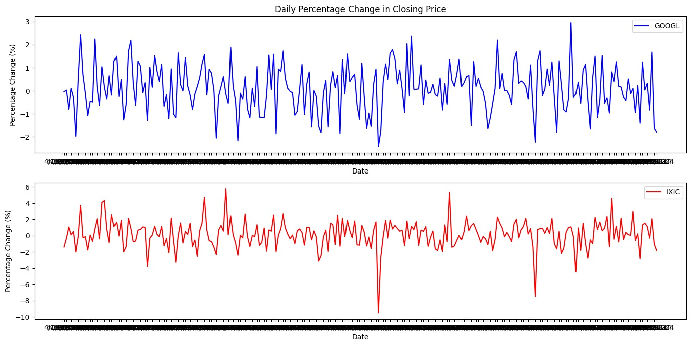

GOOGL Stock Price and 30-Day Moving Average
Over the observed period, Alphabet Inc.’s (GOOGL) stock performance shows a consistent pattern, often trading above its 30-day average price. This pattern indicates a generally positive outlook on the stock, as it suggests that more investors are buying than selling, contributing to an overall increase in the stock price. The relationship between GOOGL's daily price and its 30-day average also sheds light on the stock’s stability. When its price consistently hovers above this average, it reflects strong investor confidence, signalling that the stock is performing well. Occasionally, the price dips below this average, which, rather than indicating a downturn, often presents a buying opportunity for investors. These moments can be strategic times for new or existing investors to purchase shares at a lower price before the stock climbs again, aligning with the general upward trend.

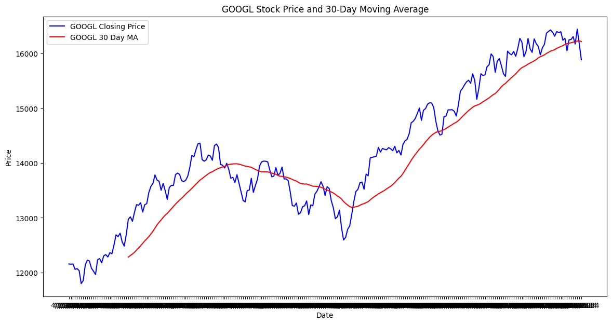
This understanding of the stock’s movement relative to its 30-day average provides a clear picture of when might be a good time to buy shares. It helps investors make informed decisions, ensuring they enter the market at moments that align with their investment strategies, all within the context of Alphabet's ongoing growth trend. This approach is key for those looking to capitalize on the dynamics of a leading technology firm’s stock in a fluctuating market.

GOOGL Stock Price with Moving Averages
In the bustling world of stock trading, Alphabet Inc.’s stock performance can be closely observed through the lens of its moving averages, a method often used to smooth out price data and get a clearer view of the trend direction. Over short periods, the 20-day moving average provides insights into the stock's recent journey, hugging close to its actual price movements and offering hints about immediate trends. On the other hand, the 60-day moving average smooths out the price data over a longer period, giving a clearer picture of the underlying trend unaffected by short-term fluctuations. When the shorter 20-day average climbs above the longer 60-day average, it signals that the stock is gaining momentum in the short term relative to its longer-term path—a sign often interpreted as bullish or positive sentiment among investors. This crossover can indicate a shift in investor confidence, suggesting stronger performance soon compared to the more gradual trends.

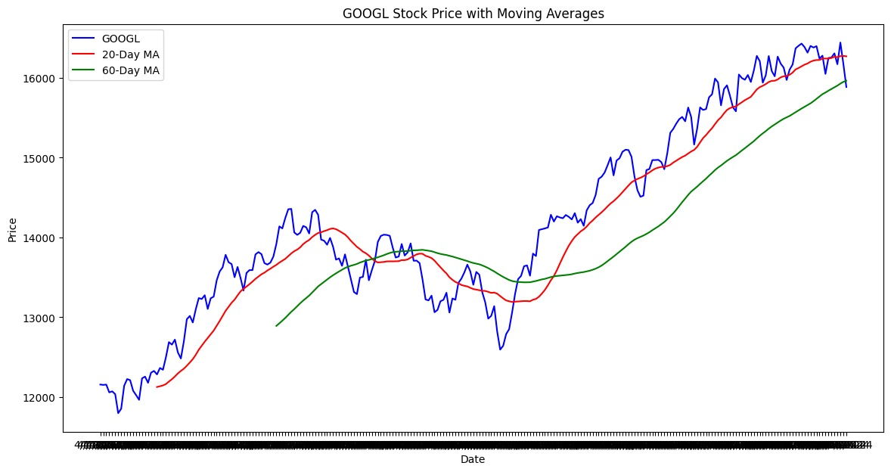

Moreover, these moving averages not only help in understanding trends but also serve practical roles in trading, acting as barriers that the stock price struggles to break through. Particularly, the 60-day moving average often acts as a floor of sorts, supporting the stock price during its dips and preventing further declines. This behavior is crucial for investors as it provides strategic points for making trading decisions, helping them identify potential buying opportunities or moments to secure profits from their investments. Overall, this comprehensive financial analysis of Alphabet Inc. provides crucial insights that help investors navigate the complexities of the stock market with informed, strategic decision-making.
Peer Comparison
In the dynamic landscape of tech investments, each company presents a unique profile that caters to different investor appetites and strategies. Alphabet, known for its dependable market performance, stands out as the beacon of stability among its peers. This consistency in its stock prices could be particularly appealing to investors who prioritize security and steady growth, preferring to avoid the rollercoaster rides often seen in the tech sector. Apple, with its robust trading activity, demonstrates a vibrant interest from the investment community, marked by both high liquidity and engaging investor participation. Its relative steadiness in stock price movement makes it a favourable choice for a broad spectrum of investors, from individuals to large institutions seeking reliable yet dynamic investment opportunities.

On the other end of the spectrum, Meta exhibits more pronounced volatility, characterized by significant daily price shifts. This tendency might attract those who thrive on quick, strategic plays in the market, capitalizing on the swift changes driven by recent news or the latest market trends. Meta's profile suits speculative investors or those with a keen eye for seizing short-term opportunities that arise from such fluctuations. Microsoft, while maintaining high average closing prices, also shows notable volatility, though not to the extent of Meta. Its investment appeal lies in its ability to offer a blend of growth and relative price stability. This combination makes Microsoft suitable for a range of investment strategies, accommodating both medium and long-term investment horizons and appealing to those looking to balance growth prospects with manageable risk levels.

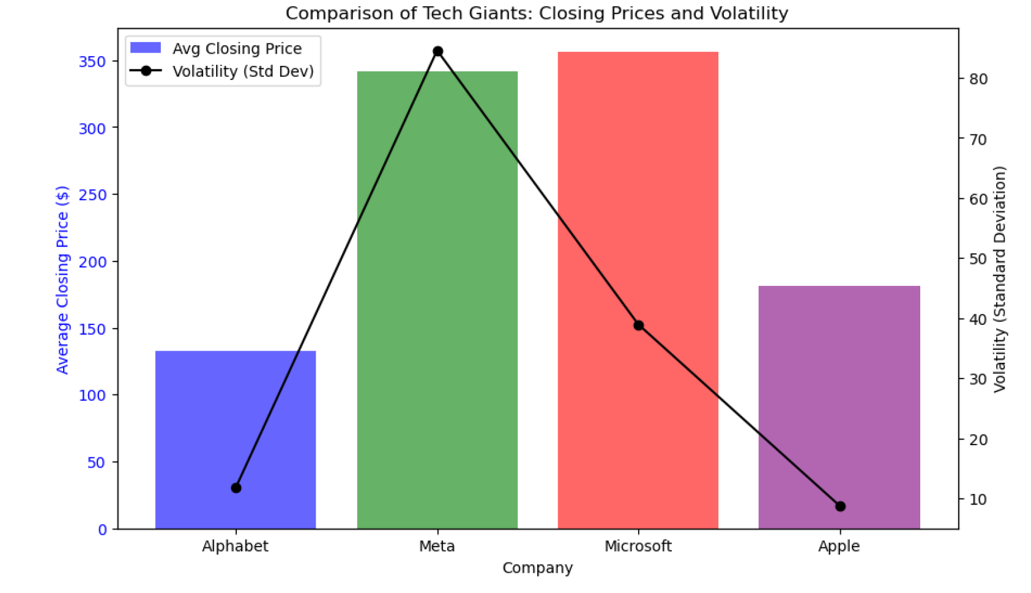

Together, these companies shape a diverse investment terrain where stability meets opportunity, allowing investors to tailor their portfolios across a spectrum of risk and reward scenarios in the tech sector. This diversity not only enhances the vibrancy of tech investments but also provides multiple entry points for different investment styles and objectives.
Economic and Sector Context
Alphabet Inc.'s financial landscape is shaped by an intricate mix of economic policies and market dynamics. Changes in tax policies and government spending can directly impact Alphabet's profitability and opportunities for growth. For example, new tax laws might increase expenses or provide savings, while increased government investment in technology could open new avenues for the company. Monetary policies, particularly interest rate changes, also play a crucial role in determining Alphabet’s borrowing costs and investment decisions. These adjustments are reflective of broader economic conditions that influence Alphabet's strategic planning.

Inflation is another key factor, as it affects both operational costs and consumer spending power. Rising inflation might lead to higher costs for Alphabet and adjust pricing strategies, impacting consumer and business spending on Alphabet's services. The wider tech market context also plays a significant role. Advances in e-commerce, mobile computing, and artificial intelligence over the past decade have driven growth in tech stocks, with Alphabet benefiting significantly due to its strong presence in search, advertising, and cloud computing. The sector's health is linked to macroeconomic elements such as consumer spending and global economic conditions. During economic booms, tech companies like Alphabet typically flourish as businesses invest more in technology. However, during downturns, spending cuts pose challenges that Alphabet must strategically navigate.

Overall, Alphabet continuously adapts to these economic and market forces, demonstrating resilience and a proactive approach to managing its diverse operations in a dynamic tech landscape.

Strategic Recommendations
For investors interested in Alphabet Inc., a variety of trading strategies and approaches can help navigate its stock performance effectively. One useful tactic involves focusing on the day's opening prices, which often predict the closing trend. Recognizing this pattern allows traders to set up profitable trades right at the start of the trading session, potentially enhancing the success rate of their daily strategies. Another key strategy is to monitor changes in trading volume. Significant increases in volume can lead to pronounced price movements, particularly downward. By anticipating these shifts—especially before major corporate events like earnings reports or product releases—investors can adjust their positions to either capitalize on quick gains or avoid sudden losses.

Short-term traders can find ample opportunities in Alphabet’s considerable daily price fluctuations. Implementing tight controls, such as stop-loss or take-profit orders, is crucial to managing the risks associated with this volatility. These mechanisms help safeguard investments against unexpected market movements, securing profits, and limiting losses. Long-term investors, on the other hand, might focus on Alphabet’s consistent long-term growth potential indicated by the upward trajectory of its 60-day moving average. Buying shares during pullbacks towards this moving average can be a strategic move, as these moments may signal temporary undervaluation within an overall bullish trend.

Investors might also consider mean reversion strategies when the stock price significantly deviates from its moving averages, particularly in a bullish direction. This approach is based on the expectation that the price will eventually revert to a longer-term average, providing opportunities for strategic entry and exit points. Following the crossovers between short-term and long-term moving averages, such as the 20-day and 60-day, can also signal timely buying opportunities. A crossover where the short-term average rises above the long-term average may suggest a short-term bullish trend is starting, offering a potential entry point for investors.

Diversification is another crucial strategy, especially given Alphabet's correlation with broader market indices like the NASDAQ. By spreading investments across various sectors or different types of assets, investors can mitigate systemic risks while still leveraging Alphabet's leadership in the tech industry. Keeping a close eye on market sentiment is also vital. Changes in consumer trends, regulatory environments, and the competitive landscape can quickly influence Alphabet’s stock performance. Monitoring these factors can provide investors with advanced insights into potential market shifts. Implementing a dynamic rebalancing approach that responds to technical indicators such as moving averages and volatility levels can also be beneficial. This strategy involves adjusting the weighting of Alphabet’s stock in a portfolio in response to these indicators, helping investors respond to market conditions proactively. Lastly, aligning investment strategies with Alphabet’s calendar of corporate events can optimize investment outcomes. Product launches, regulatory decisions, and earnings reports can all trigger increased trading volume and price volatility, presenting strategic opportunities for adjusting investment positions.

By integrating these strategies, investors can make more informed decisions, effectively managing their exposure to risks while capitalizing on opportunities for growth presented by Alphabet's market behavior. Each strategy should be considered within the context of the investor's overall financial goals, risk tolerance, and market outlook to ensure it complements their broader investment plan.

Conclusion
In conclusion, our thorough examination of Alphabet Inc. paints a picture of a fertile investment terrain. Alphabet stands as a pillar in the technology landscape, showing both resilience and a steady climb in its stock performance, which is underpinned by consistent growth in closing prices and vigorous trading activity. The regular alignment in daily price movements adds a layer of predictability and security, making it attractive to both nimble traders and those looking for long-term value. The strong link between Alphabet's stock and the NASDAQ Composite Index, along with the ability of trading volumes to predict closing prices, marks it as a key indicator of trends in the tech sector and the wider market. Nonetheless, the stock's variability, highlighted by its daily price swings, calls for a thoughtful and strategic approach to investment. Employing moving averages helps pinpoint ideal times to buy or sell, refining the tools investors have at their disposal. While the stock’s fluctuations can create chances for quick gains, they also demand a solid strategy for managing risk and taking the market's pulse.

Investors need to stay alert, flexible, and forward-thinking to make the most of Alphabet's potential amidst these complexities. Our tailored strategic recommendations are crafted to enhance the investment potential while safeguarding against risks, steering investors through Alphabet's evolving story. Alphabet’s narrative is intertwined with the innovative spirit of the tech sector. For investors, this means that diligence, nimbleness, and foresight are crucial to harnessing opportunities and achieving superior returns amid the intricacies of the market.

